# User Guide

# Matlab Load Path Plotting Algorithm Version 1

# December 2018

## Plotting Load Paths for mesh and stress files using the Hex8 3D finite element

## D. Kelly, G. Pearce and K. Schroder-Turner

This User Guide describes features of the MatLab program prepared for release at the AIAA SciCom 2019 Conference, San Diego 7-11 January 2019 [1]. The program reads mesh data and stresses from text files created by a finite element solution that is run independently by the user. It then defines the vector field and plots the load paths using the Runge-Kutta plotting algorithm described in the paper.

The MatLab application can be downloaded from the GitHub website …..(give address and download instructions). The site contains the source of the program, and a number of example sets of data.

## Installation

Download the files in the director “Load-Path-Plotter – AIAA – V1” to your chosen MatLab run directory.

To launch the program nagivate to your chosen directory and select the LoadPathGui file and press “Run”. The graphical user interface show below will appear.

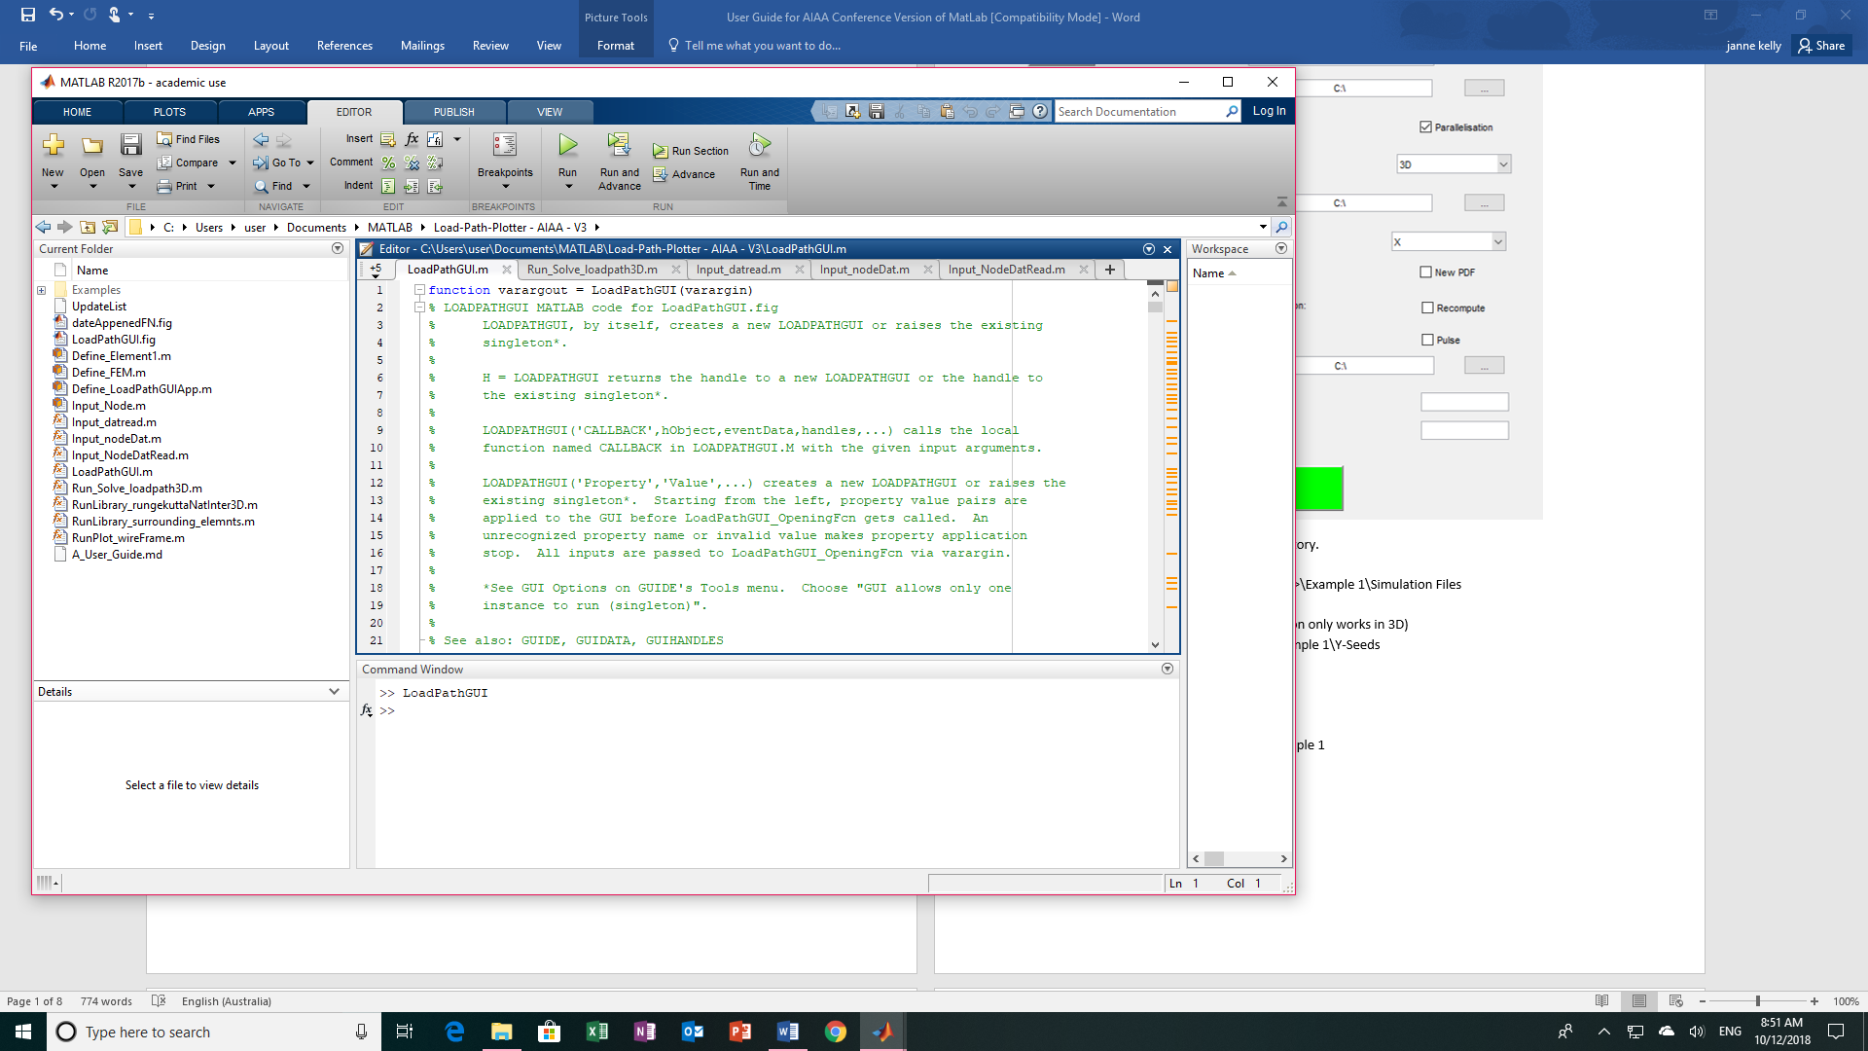

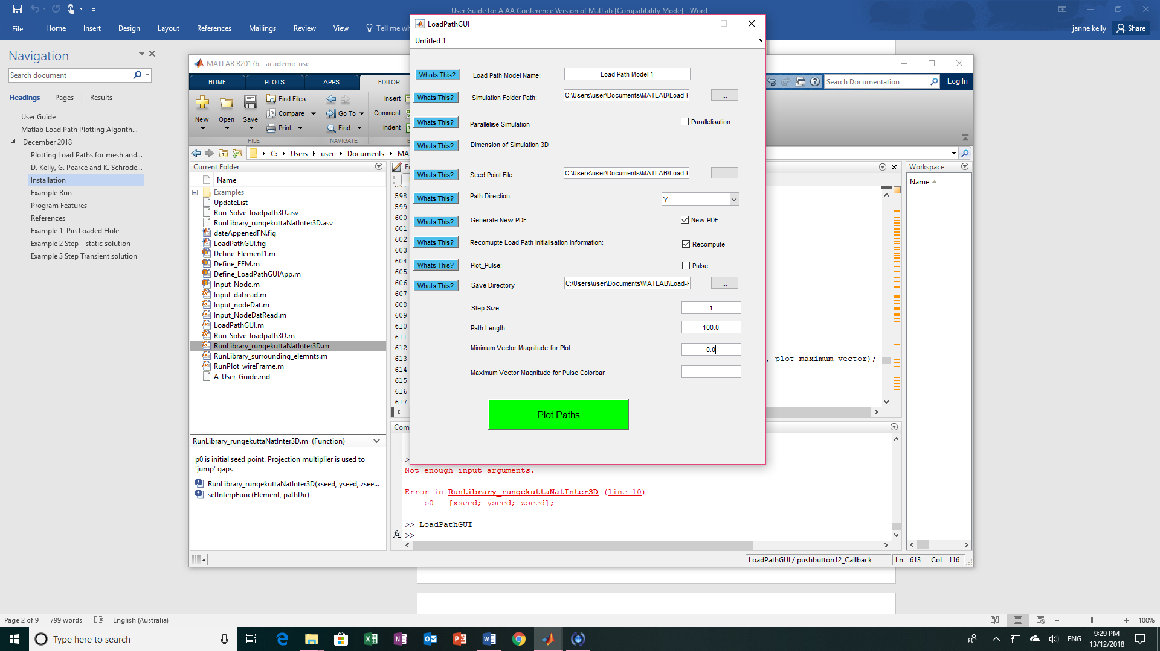

## Example Run

To run the first data set in the Examples Directory.

Simulation Folder Path

<MatLab run directory>\Examples\Example 1 Isotropic Plate With Loaded Hole\Simulation Files

Parallelisation tab – No

Dimension of Simulation – 3D (current version only works in 3D)

Seed Point File

<MatLab run directory>\Examples\Example 1 Isotropic Plate With Loaded Hole\Y-Seeds (Primary)

Path Direction – Y

New pdf – Yes

Recompute – Yes

Save Directory - <MatLab run directory>\Examples\Example 1 Isotropic Plate With Loaded Hole

Step Size – 1

Path Length – 100

Minimum Vector Magnitude for Plot – 0.0

Plot Paths … following image will be created

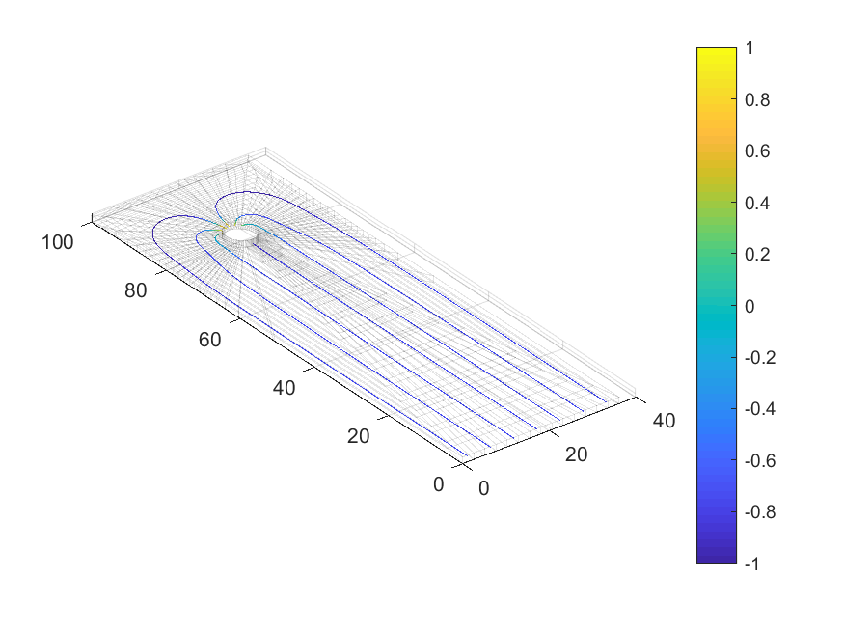

## Program Features

1. Only works for finite element mesh and stress files created using Hex8 elements (8-noded 3d bricks)
2. The program reads node coordinates and element connectivity from a file (ds.dat) written to a fixed format.
3. The program reads node stresses from a file (nodalSolution.txt) written to a fixed format.
4. The contours are generated by a Runge-Kutta algorithm (see Reference [1]).
5. Commencing points for the contours are defined
   1. In a file xxxx.dat identified in the GUI created when the program is run.
   2. If the file is empty the Seeds are generated by the program. A seed is located at the centroid of element with the maximum magnitude of the Load Path Vector selected for the plot. Seeds are created on other elements with the same coordinate (in the Load Path Vector direction) to form a rake. This method facilitates the plot of the pulse.
6. The program ensures the normal vectors for all element faces on the HEX8 elements point outwards
   1. Define centroid of element and store in an array
   2. Define centroid of face and vector V1 from centroid of element to centroid of face
   3. Define normal to face Vn as vector cross-product of two edges (store in array)
   4. If vector dot product V1.Vn is positive – ok
   5. If vector dot product V1.Vn is negative – reorder nodes on face and reverse direction of Vn.
7. A simple code is used to determine which element point p0 is inside – may not work for highly distorted meshes.
   1. Loop over all elements
   2. Loop over all faces of the element
   3. Form vector V2 from centroid of the face to p0.
   4. Calculate the vector dot product of V2 and outward face outward normal.
   5. If all dot products are negative or zero p0 is in that element or on the surface of the element.
   6. If vector dot product is positive for any one face, p0 is outside element.
8. For plot of transient propagation of pulse – see blocks of code ‘if pulse == 1’ in loadpath3D.m
   1. Plot only peak of pulse – In GUI set minimum below which path will not be plotted.
   2. In GUI set maximum for colorbar from review of finite element. Same maximum to be used across all time steps so plot will show change in maximum.
9. To create movie
   1. Create a set of result files at different time steps
   2. Run load path program for each result file and store image as bmp file
   3. Run separate Movie.m program to create avi file.

## References

[1] D. Kelly, G. Pearce and K. Schroder-Turner. “Plotting Load Paths from Finite Element Stress Results for Aerospace Structures” Proceedings SciTech 2019, January 7-11, San Diego 2019.

## Example 1 Pin Loaded Hole

Y-direction load paths



X-direction load paths

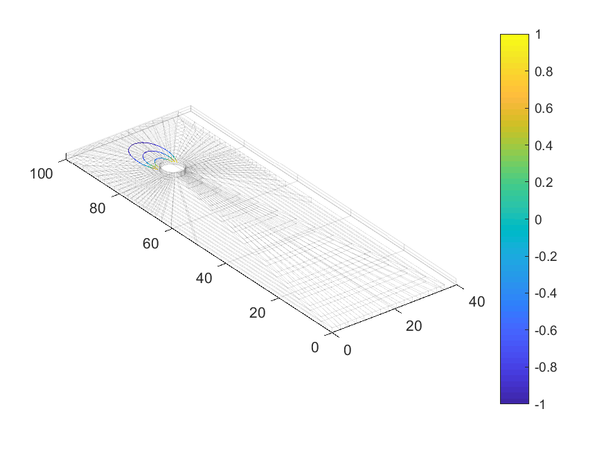

## Example 2 Step – static solution

Parula colorbar

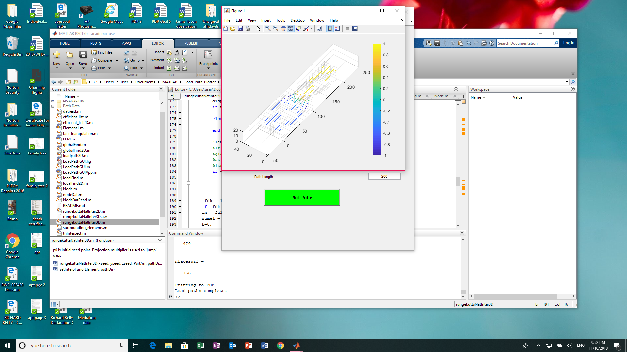

## Example 3 Step Transient solution

FEA result at step 8

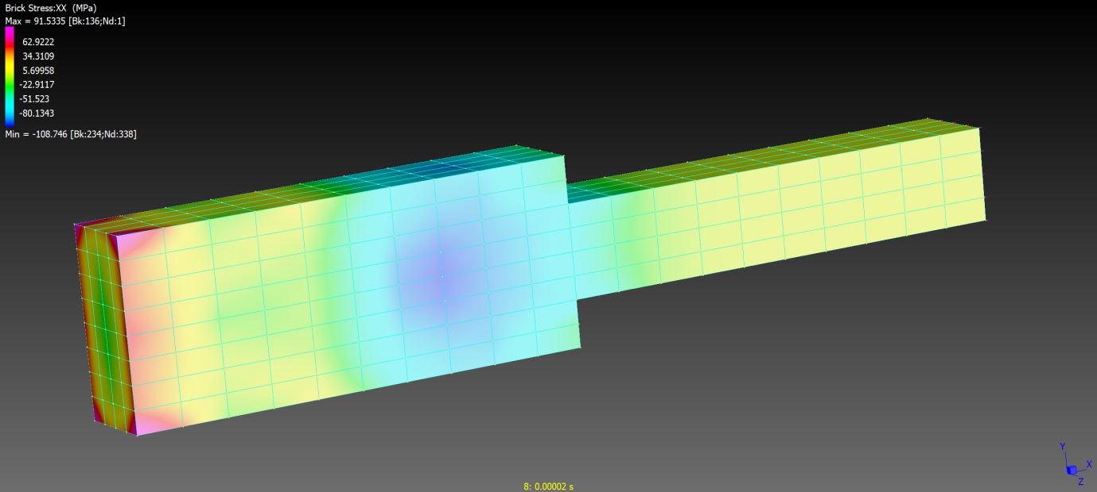

X-direction load paths at step 8 (inverted hot colorbar)

